
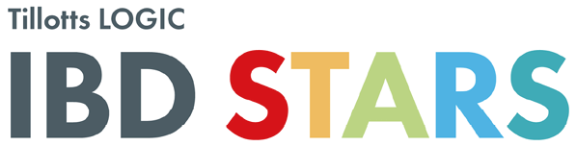
For UK and Ireland healthcare professionals only. Some of this educational content may contain reference to Tillotts products. Organised and funded by Tillotts Pharma UK and Ireland.

Tillotts LOGIC IBD STARS, Rising Star Award Entry
Applications to be sent to: LOGICIBDSTARS@tillotts.com

Nominee Contact Information – Details of the colleague you are nominating.

Their full name
Their job title
Their institution / hospital
Their contact detail

Applicant Contact Information – Please fill in your own details.

Your full name
Your job title
Your institution / hospital
Your contact details

Please tick the relevant criteria applicable to the entry  Please note: applicants must have been in their current IBD Nursing role for no more than 3 years | To recognise an IBD Nurse who shines by:  ☐ Demonstrating a passion and enthusiasm for their role.  ☐ Exhibiting teamwork excellence.  ☐ Being patient focused and strives to improve patient care.  ☐ Inspiring others to shine and demonstrates great dedication in supporting other colleagues.
Provide a summary of why the applicant is a ‘Rising Star’
(300 words only)
Provide an example of how the applicant has demonstrated that they are a ‘Rising Star’

